|  |  |
| --- | --- |
| EGC_Black | **Eastern Goldfields College**  ***Year 12 MATHEMATICS METHODS***  ***TEST 1 2016*** |

Name : \_\_\_\_\_\_\_\_\_\_\_\_\_\_\_\_

**Total Marks: 30**

**Reading: 2 minutes Time Allowed: 32 minutes**

1. [2, 2, 2, 2, 3 marks]

Find the derivative of the following, do not simplify.

a 

b 9(x3 + 1)3

c 

d [1 + sin(2x)]7

e 2x(3x – 4)5

**2 [3 marks]**

Given that the equation of a curve is *y* = 3*x*3 + 4*x*2 + 5, find the approximate increase in *y* as *x* increases from 2   
to 2.02.

3 [4, 3 marks]

Find the gradient of the tangent to each curve:

a y =  at x = 5

b y = cos  at x = π

4 [4, 5marks]

Find the equation of the tangent to each curve:

a y = e4x at the point (2, e8)

b y = tan(x) at the point where x = .

Name : \_\_\_\_\_\_\_\_\_\_\_\_\_\_\_\_\_\_\_\_\_\_\_\_

|  |  |
| --- | --- |
| EGC_Black | **Eastern Goldfields College**  ***Year 12 MATHEMATICS METHODS***  ***TEST 1 2016*** |

CALCULATOR AND RESOURCE RICH

**Total Marks: 31**

**Reading: 2 minutes Time Allowed: 33 minutes**

5 [2, 3, 2, 1 mark]

The displacement of an object from a particular point is given by s = 2t3 + 9t – 8, where s is in metres and t is   
in seconds.

a Find the velocity at 2 s.

b Find when the velocity is 15 m/s.

c Find the acceleration at 2 s.

d Find the acceleration when the velocity is 15 m/s.

6 [3 marks]

Sketch a curve where f ″(x) > 0 for x < 0, f ″(x) < 0 for x > 0 and f ′(x) < 0 for all x.

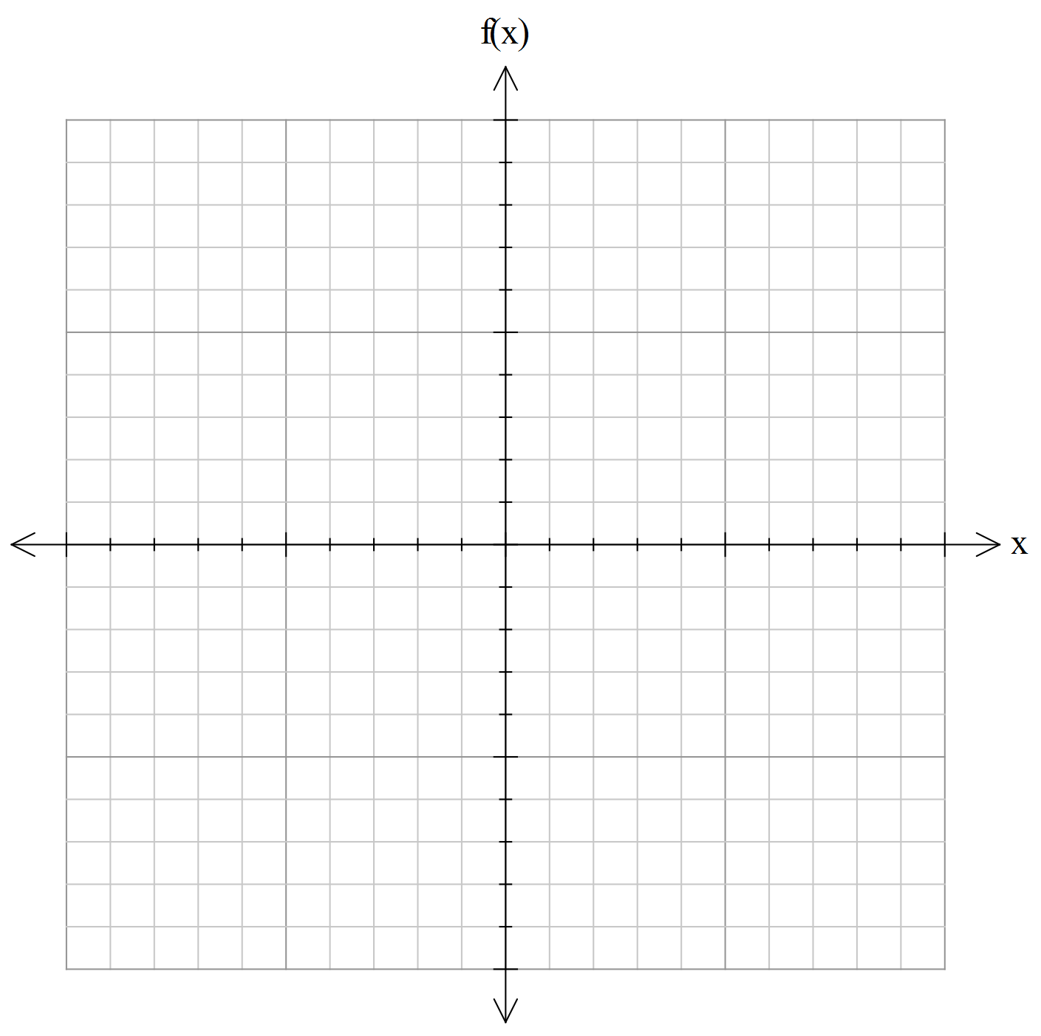

*7 [6 marks]*

A baseball player strikes the ball so that its equation of motion is given by h = 2x – 16 – 0.05x2, where h is the height (in metres) reached by the ball and x is the horizontal distance (in metres) travelled by the ball. What is the greatest height reached by the ball?

8 [8 marks]

A soft drink manufacturer produces cylindrical aluminium cans, each with a volume of 500 mL (i.e. 500 cm3). What is the radius of the can if the least amount of material is to be used in its construction? Give your answer correct to 2 significant figures.

9 [1, 1, 2, 2] A long-term project to help people in Beachtown gain employment uses a model of

N = 2400e–0.11t for the number of unemployed people over t years.

a How many people were unemployed at the start of the project?

b How many people were unemployed after 6 years?

c What was the unemployment rate:

i initially?

ii  after 6 years?